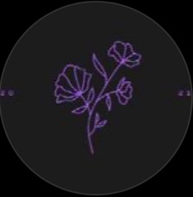

LURID PURPLE FLOWERS

RELEASE DEBUT EP “MANIA”

UPCOMING TOUR TEASED

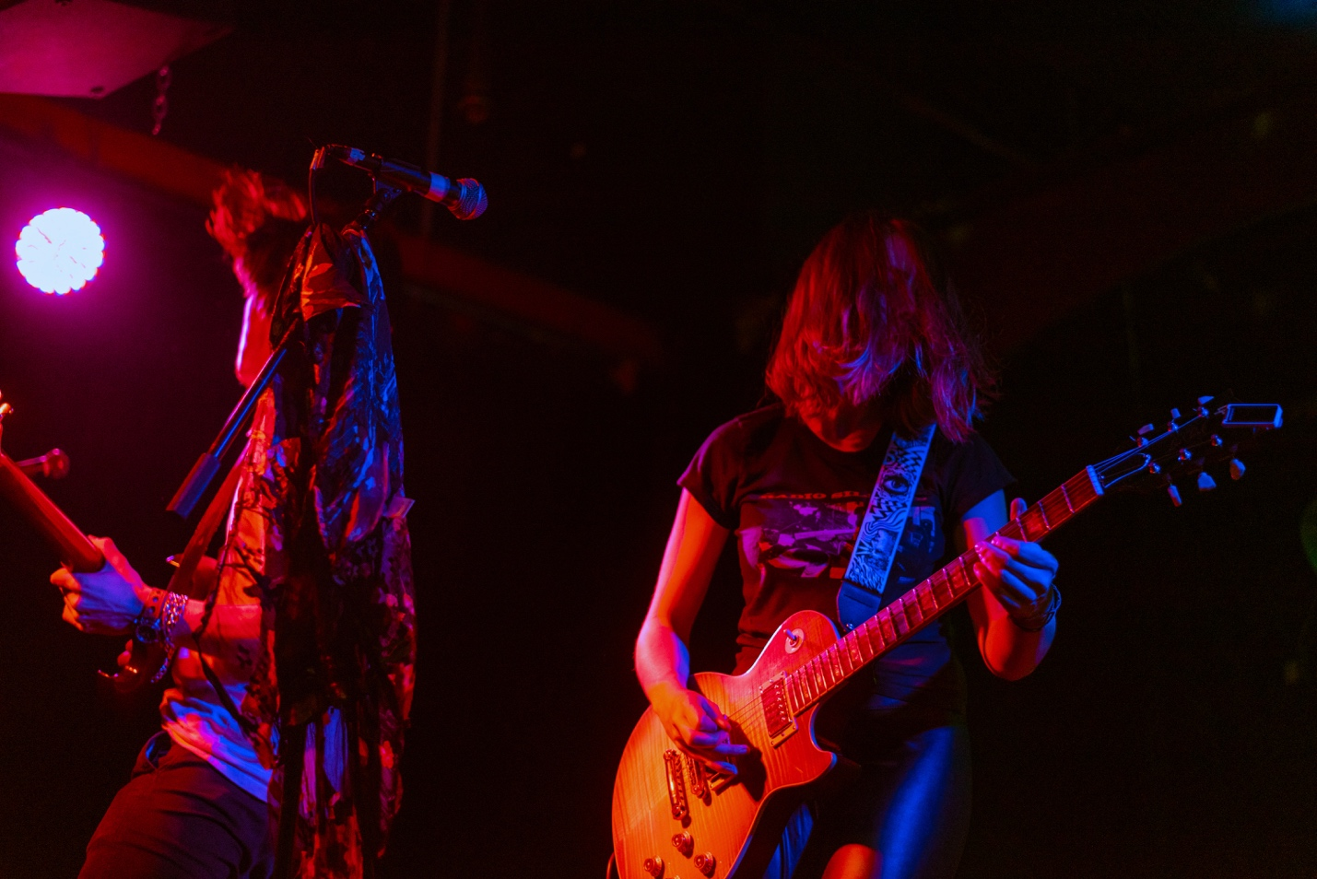
Photo Credit: Helaine Bach (download hi-res)

Pictured (Left to Right): Ben Caito (Guitar)), C.A. Newcomb (Vocals/Guitar),

Lurid Purple Flowers, the collective born of artists from around the United States, share with the world “MANIA,” a collection of heartfelt heavy rock songs that breathe new life into a genre that has long gone stale. The lead single “Darkness” hit streaming platforms to an extremely positive reception, with the EP garnering over fifty thousand streams at the time of this release. It has have also received fair amounts of college radio airplay in over twenty-five states, just cracking the NACC top 200 as of 2/18.

“Darkness embodies the themes of giving everything and receiving nothing in return. The brutal reality of devoting yourself and getting spit on, and the exhaustion of trying to be good enough for someone who is hurting you. The chorus is meant to defiantly lash out, but at the same time plead ‘Darkness, please don’t take Me.’ During the course of our recording sessions at Leesta Vall Studios in Brooklyn, as well as our live shows in the summer of 2021, we gradually increased the tempo and intensity of the track until it truly embodies these intense feelings. For me, the song defines Lurid Purple Flowers as a band. It has taken us through two years and a lot of hurt, both personally and professionally.”
- Frontwoman and guitarist C.A. Newcomb

The lead single, Darkness was teased with a video of it being performed live at The Middle East Nightclub surfacing on Youtube in the late summer of 2021.The next month, LPF released the song on Halloween at midnight, which was immediately hailed by Indie Dock and Sinusoidal Music for the “Frenzied energy of its drive” and “The lyrics that speak to your hidden voice.” The artists ready themselves for a summer of live shows to support their release.

Visit their website or their official Instagram for more information.

SHOW DATES:

2/25 – Somerville, MA @ Warehouse XI
2/26 - Pawtucket, RI @ News Cafe
3/5 – Jamaica Plain, MA @ Midway
3/11 – Worcester, MA @ Ralph’s Rock Diner
4/2 - Manchester, MA @ Shaskeen
4/9 Littleton, NH @ The Loading Dock
4/15 Boston, MA @ The Red Room w/Quarters of Change
4/16 Boston, MA @ Brinstar
4/22 Boston, MA @ Harvard University
4/23 Somerville, MA @ The Jungle

